***Types of valves***

There are many types of valves, we will talk about major types and their classification

***Types of valves:***

1-Multi-Turn Valves 2-Quarter-Turn Valves 3-Check Valves

**1-Multi-Turn Valves:**(linear motion valves)

The closure member has a linear displacement generally by turning its threaded stem several times.  
This operation is slow, but it gives accuracy and stability to position the closure member, which is necessary in some control valves.

Types of Multi-Turn valves: Gate valve, Globe valve, Fixed cone valve, Needle valve and Pinch valve.

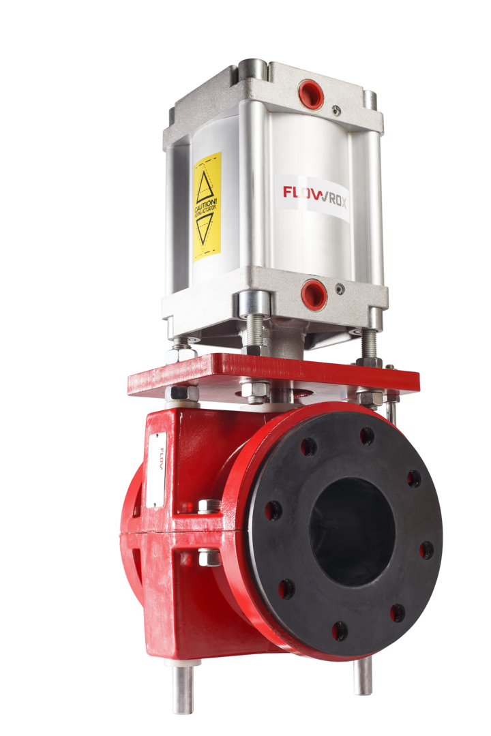

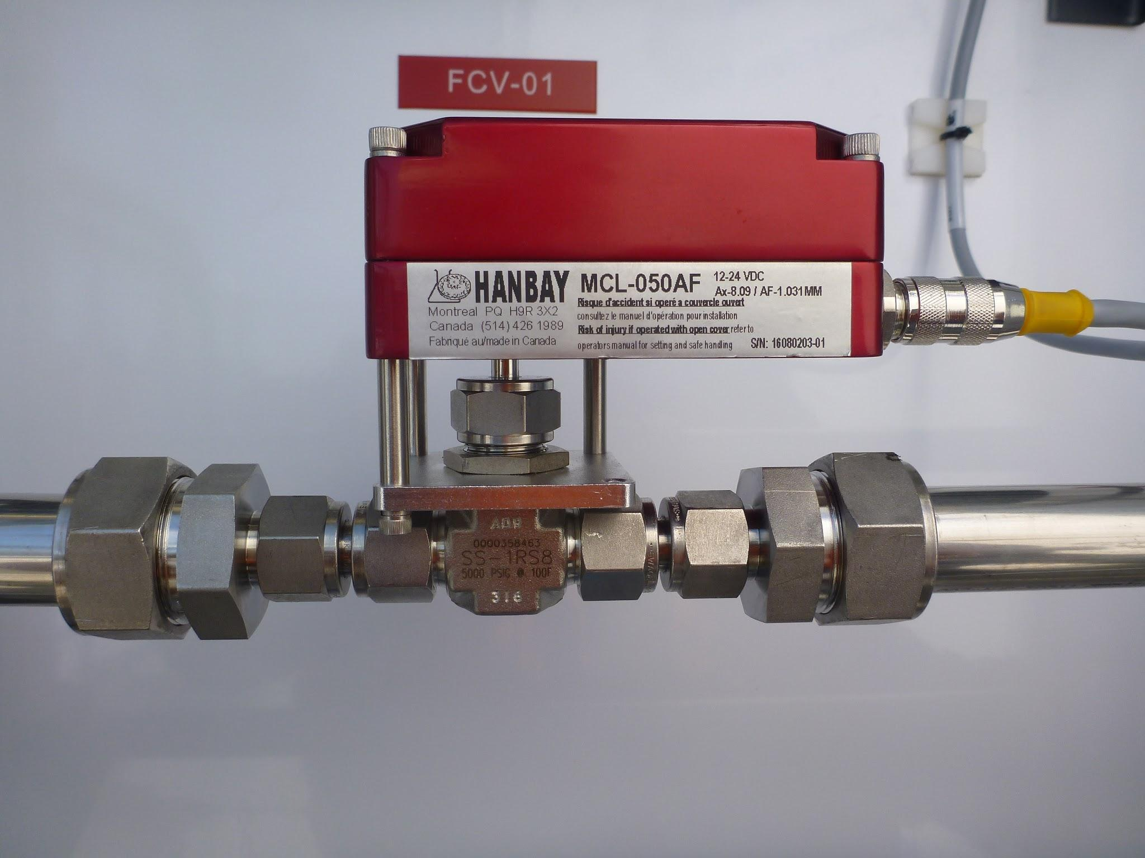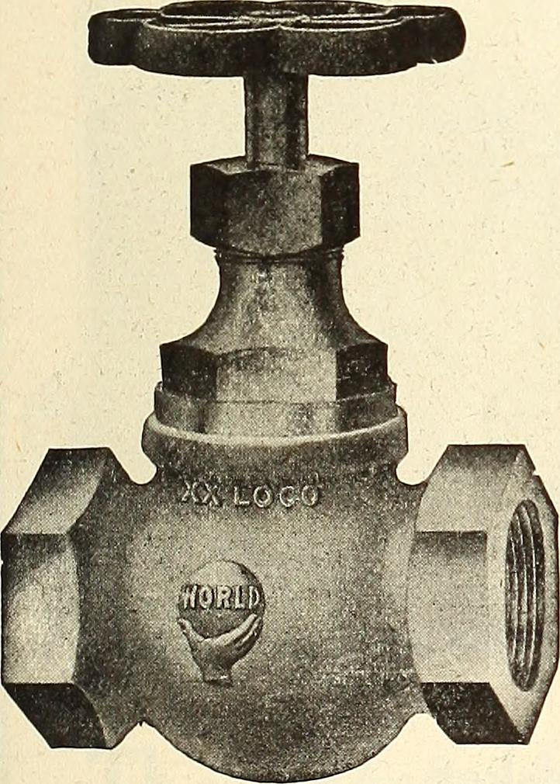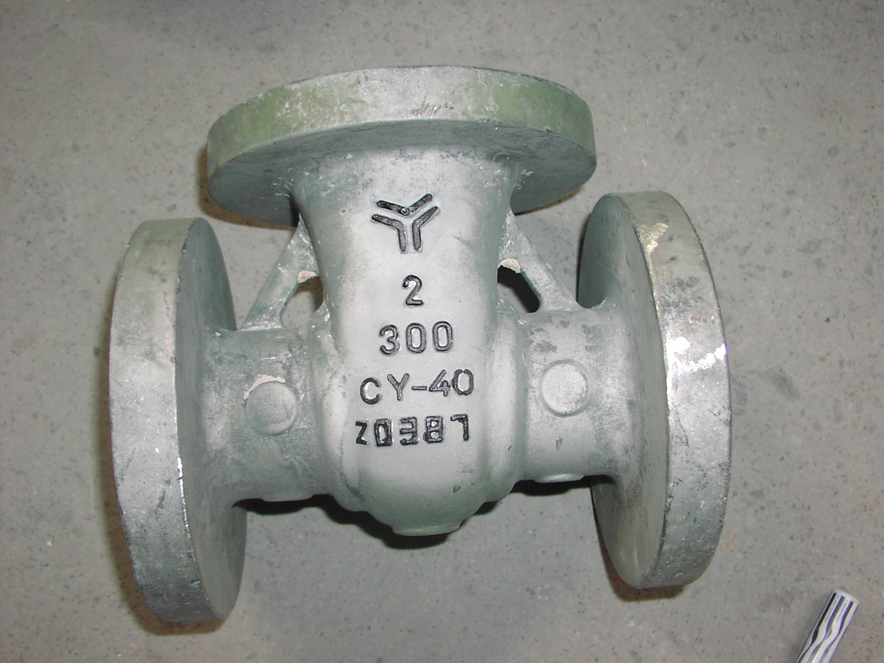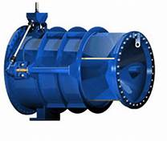Gate valve Globe valve Fixed cone valve Needle valve Pinch valve

**2-Quarter-turn valve:** (rotary valve)

The closure member as well its shaft turn 0º-90º; from the fully-open position to the fully-closed position.   
They are quick opening/closure valves.  
  
Types of quarter-turn valves: Ball valve, Butterfly valve, Plug valve, Spherical valve.

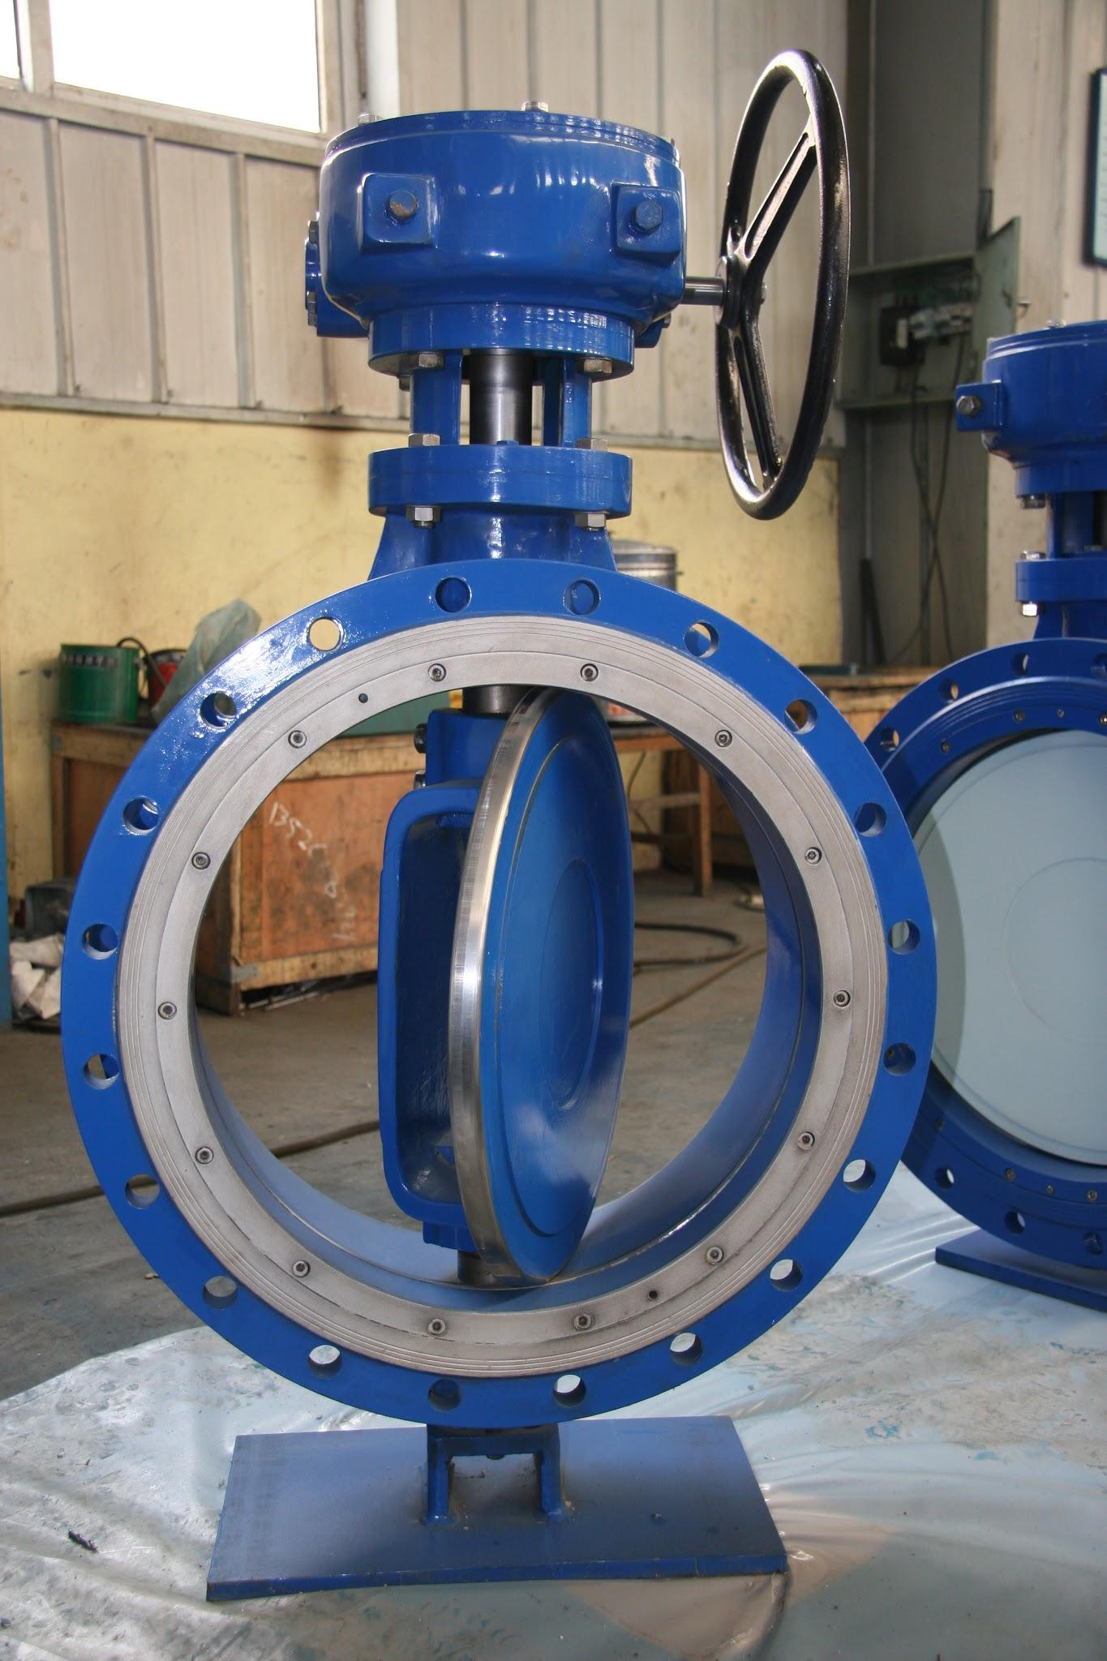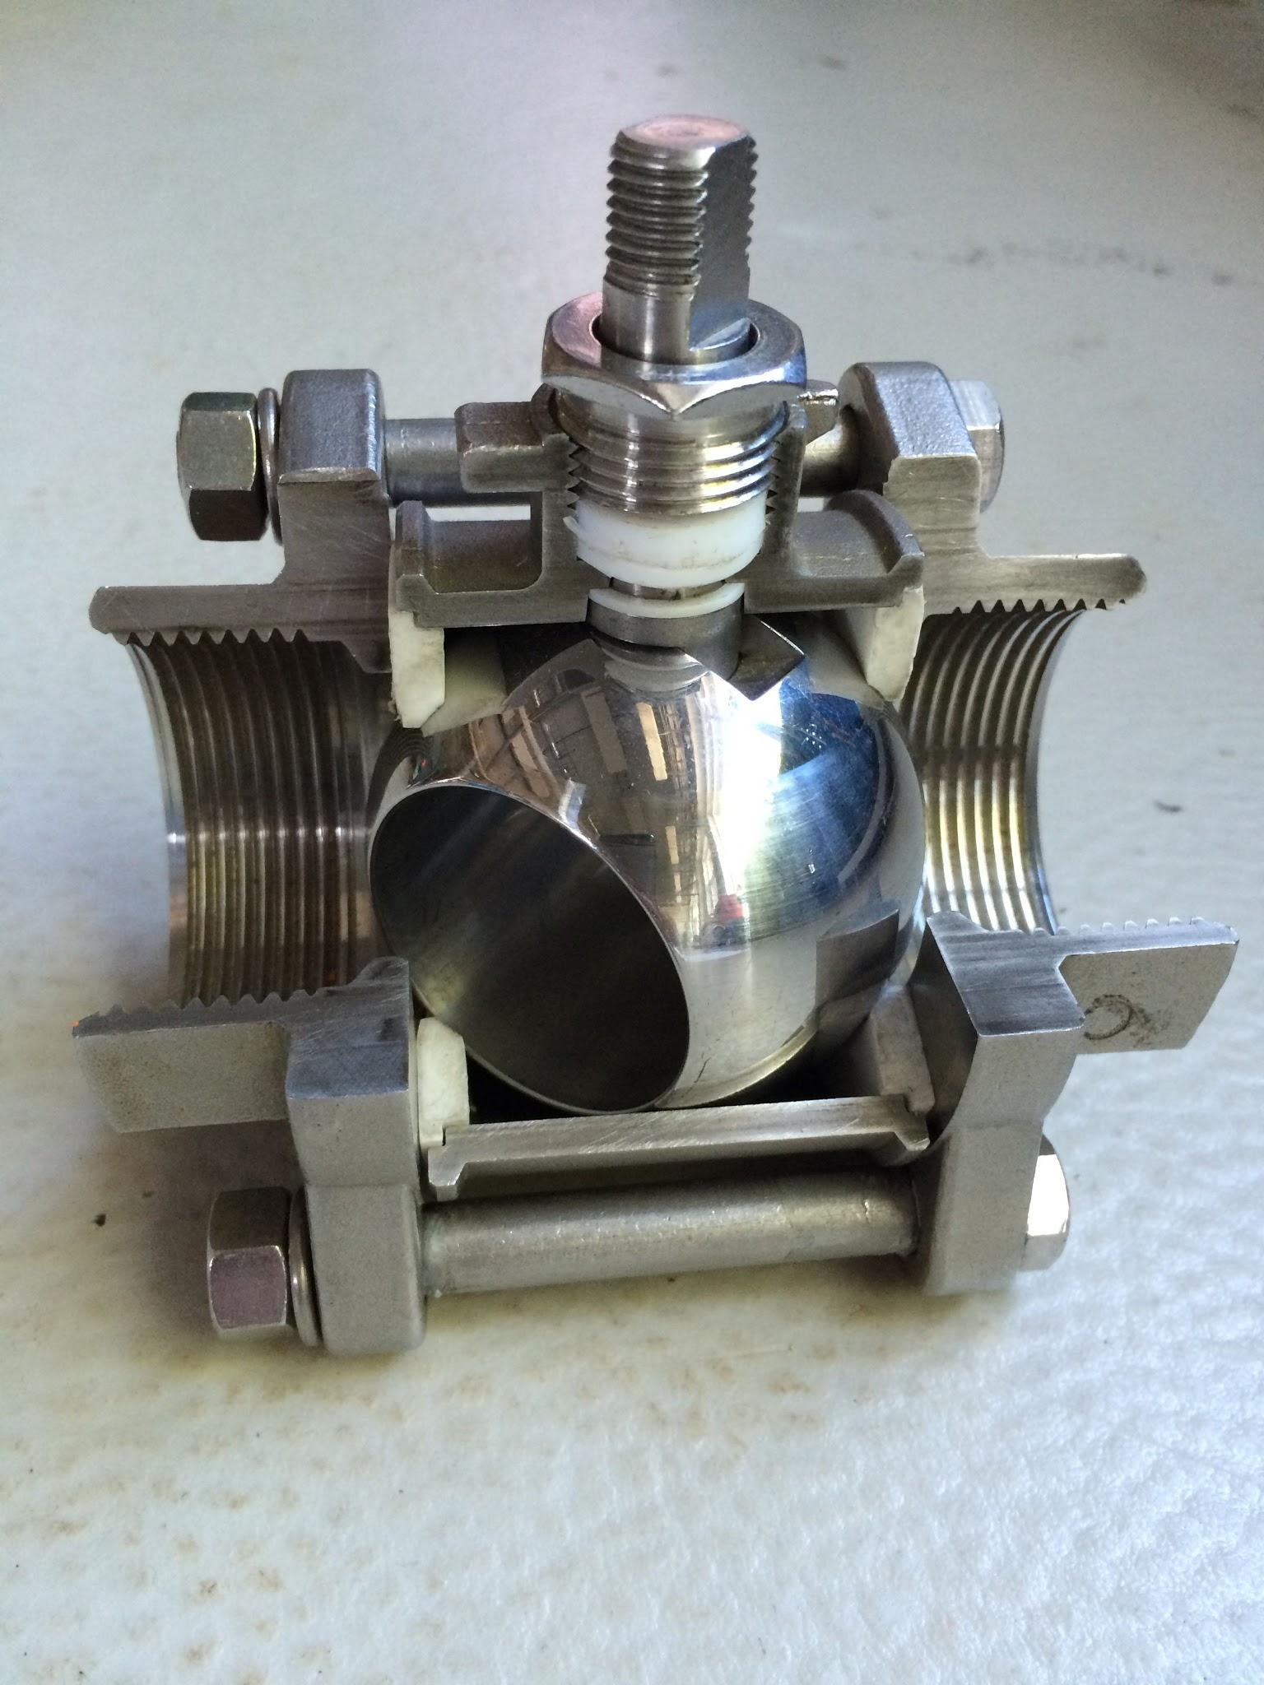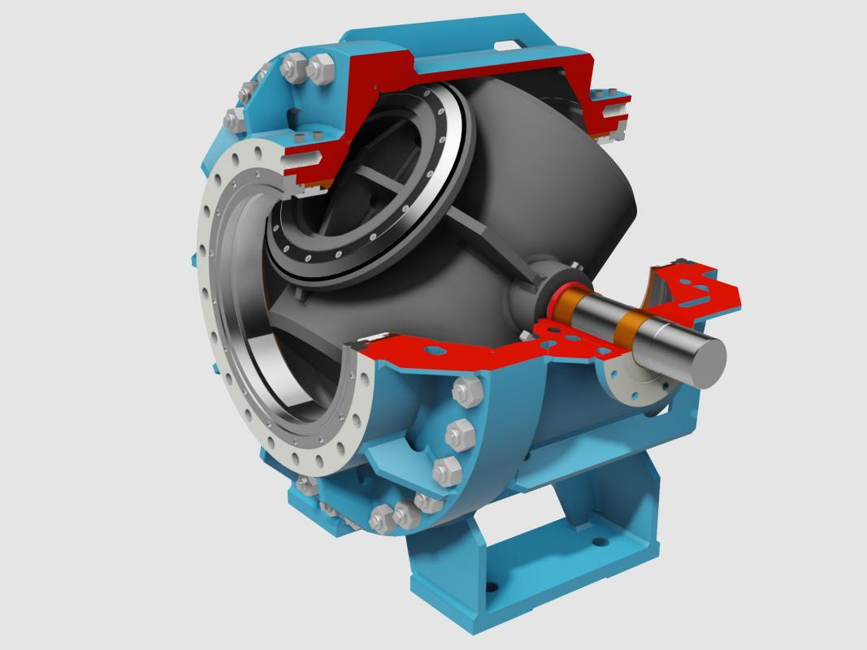

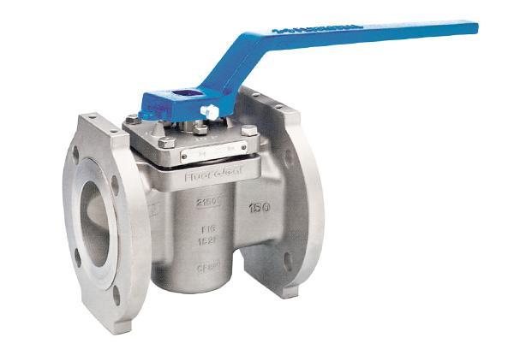

Ball valve Butterfly valve Plug valve Spherical value

**3-Check valve:**

allows flow in one direction and automatically prevents back flow (reverse flow) when fluid in the line reverses direction. They are one of the few self-automated valves that do not require assistance to open and close

Types of check valves : Rubber duckbill check valve ,Tilting disc check valve ,Swing check valve

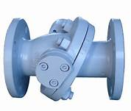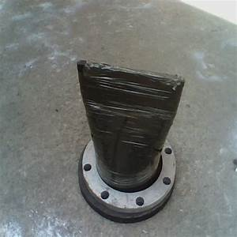

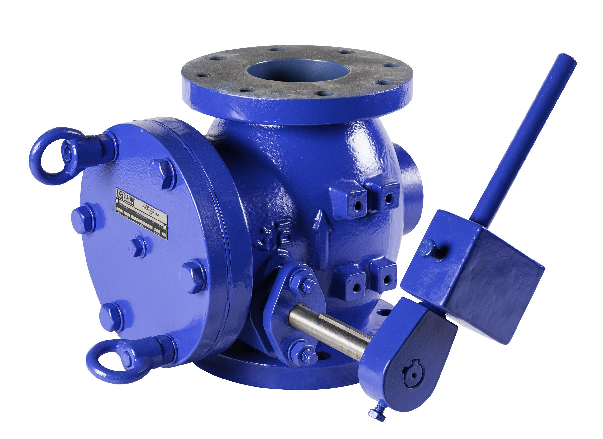

Rubber duckbill check valve Tilting disc check valve Swing check valve

**4-Safety Valves:**

The primary purpose of a safety valve is the protection of life, property and environment. A safety valve is designed to open and relieve excess pressure from vessels or equipment and to reclose and prevent the further release of fluid after normal conditions have been restored.   
  
A safety valve is a safety device and in many cases the last line of defence. It is important to ensure that the safety valve is capable to operate at all times and under all circumstances. A safety valve is not a process valve or pressure regulator and should not be misused as such. It should have to operate for one purpose only: overpressure protection.

Reason for excess pressure in vessels:

Most common reason :

1)Blocked discharge  
2)Exposure to external fire, often referred to as “Fire Case”  
3)Thermal expansion  
4)Chemical reaction  
5)Heat exchanger tube rupture  
6)Cooling system failure

There are two main types of safety valves: Spring loaded safety valves and pilot operated safety valves.

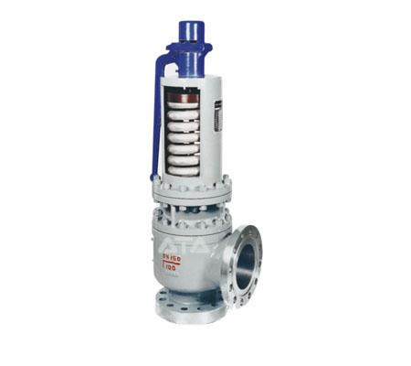

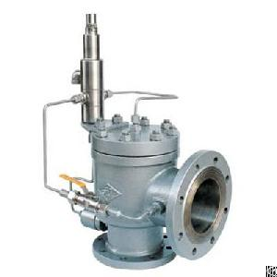

Spring loaded safety valve pilot operated safety valve